**Bug Title:**

**[Our Store]: Google Maps Can’t Load Pop-up Error Always Appear When Accessing Our Store Page.**

**Bug Description:**

This issue occurs when user access the Our Store page. User **notice that the Google Maps Can’t Load Pop-up Error Always Appear When Accessing Our Store Page.**

**Expected Result:** Google Maps should be loaded and displayed properly so user can find the store easily.

**Actual Result:** Google Maps could not be loaded and displayed properly.

**Steps:**1. Launch Browser.  
2. Go to automation practice.com.

3. Click “Our Store” link on footer of the website.

4. Observe the “Our Store” page.

5. Notice that the Google Maps Can’t Load Pop-up Error Always Appear When Accessing Our Store Page.

Attachment:

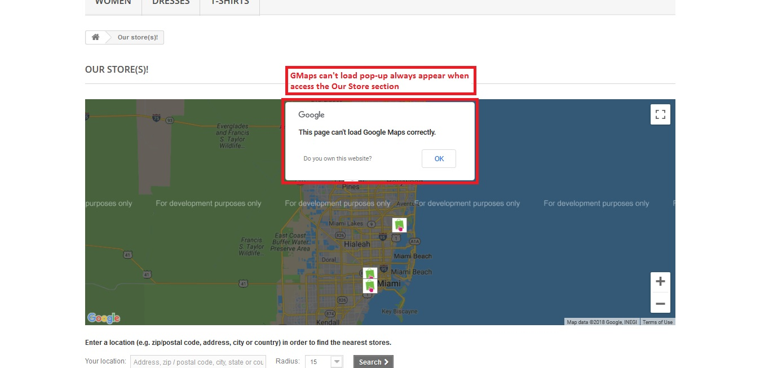

**Bug Title:**

**[Product Compare]: The Text Should Be Changed To “Remove From Compare” Since The Item Already Added To Comparison List.**

**Bug Description:**

This issue occurs in product list. User observe the product list and add item to comparison list by clicking the “Add to Compare” button. Then, if user want to remove the item from comparison list, user **notice that the text should be changed to “Remove From Compare” since the item already added to comparison list.**

**Expected Result:** The button should be changed to “Remove From Compare” if user want to remove the item from comparison list.

**Actual Result:** The text on the button still written “Add to Compare”.

**Steps:**1. Launch Browser.  
2. Go to automation practice.com.

3. Observe any item.

4. Click the “Add to Compare” button.

5. Click again the button to remove item from comparison list.

5.Notice that the text should be changed to “Remove From Compare” since the item already added to comparison list.

Attachment:

